Final Project Report

Simulating Mammography screening for Breast Cancer

**AUTHOR**: Dana Alsagheer (1088556)

FUNDAMENTALS OF MEDICAL IMAGING

**TABLE OF CONTENTS**

**ABSTRACT …**…………………………………………………………… 3

**INTRODUCTION** …………………………………………………………… 4

* Background

**METHODOLOGY** …………………………………………………………… 5

* Algorithm
* KeyTerms
* Input Parameters
* Output Methods

**CONSTRAINTS** …………………………………………………………… 8

* Breast Tissue Density
* Cancer Tissue Density
* Location of Cancer

**RESULTS** …………………………………………………………… 10

**COPY OF THE CODE ……………………**……………………………… 14

**CHALLENGES** …………………………………………………………… 18

**CONCLUSION** …………………………………………………………… 18

**REFERENCES** …………………………………………………………… 19

**ABSTRACT**

Mammography is a high-quality imaging technique the detection of breast cancer, which requires dedicated equipment and optimum operation. Both of the design parameters of a mammography unit and the optimum operational parameters have to be decided and evaluated before the construction of such a high cost apparatus. My aim is to implement a virtual mammography system simulates anatomies and the attenuation co-efficient of various tissues and lesions, effect of x-ray beam energy and contrast. As in a standard mammography we will start with a virtual 2D breast phantom at a compressed arrangement. Then will add different structures like lesions and adipose tissue by giving those corresponding sizes and attenuation coefficients. Then set the x-ray machine and create its images. To Find the effects of:

* Changing sizes of Breast Tissue
* Varying X-ray energy
* Relative position and sizes of cancer

My program will consider the effects of various cancer sizes, breast sizes and changing the X-ray energy. Also, the simulator’s ability to detect the tumor, and the position of it calculate the relative Intensity and difference in contrast and show it on a graph. The phantom is kept basic and more attention was given to study the varying attenuation coefficients and densities of tissues because we want the study to focused on understanding the algorithm for applying XRAYS to phantom.

**INTRODUCTION**

BACKGROUND

According to the American Cancer society

* Breast cancer is one of the leading causes of cancer mortality among women in the United States.
* A woman's chance of developing invasive breast cancer at some time in her life is approximately 1 in 8 (12%).
* Breast cancer typically produces no symptoms when the tumor is small and most easily treated, which is why screening is important for early detection.

The death rate from breast cancer has decreased by 34% between 1990 and 2010 in the United States because of early detection, intervention, and postoperative treatment, breast cancer mortality has been decreasing. Mammography is the preferred screening examination for breast cancer. It is widely available, well-tolerated and inexpensive.

Screening mammography is the greatest contribution to early detection and decreasing in breast cancer mortality, although its use has resulted in a minor increase in the number of in situ cancers detected.

A screenshot of a cell phone


**METHODOLOGY**

Mathematical phantoms are essential for the development and early stage evaluation of image reconstruction algorithms in x-ray. This study offers tools for computer simulations using a two-dimensional (2D) phantom that calculates the intensity, thickness and mass-attenuation co-efficient of various slices. The tool is for use with Matlab®, as well as open-source variants, such as FreeMat and Octave, which are all widely used in both academia and industry. To get started, the interested user can simply copy and paste the codes into Matlab® M-files.

**ALGORITHM**

We used MATLAB to create our application with a default image size is set to 1000. The GUI has the following selection: X-Ray Intensity (Io), the breast size and the size of four different cancers. First a phantom is created with two 1000x1000 2D matrix filled with 0s.

One matrix is for the attenuation coefficients of the tissues and the other is for the densities. The Breast is created using the input size and centered in the 2D matrices.  The three cancers are stored in the phantom if their sizes are greater than 0. The cancers have random x and y start coordinates to make each figure unique and exciting.

Once the phantom is created, we simulate an X-Ray coming from the top of the 2D image. An Intensity matrix is created with all ones that is an image size (1000) by 1 matrix that is used to store the intensities. We take the intensity of each vertical slice starting from the left.

Each slice is calculated by storing the attenuation and density of the first row and setting the length from the X-ray to 1. Then each row is examined and if the attenuation/density match then length is incremented else the X ray Intensity formula is applied and multiplied by the current value in the intensity array**:**

**intensityArray(col) = intensityArray(col) \* (Io \* exp((currentAttenuation)\*currentDensity\*length)).**

After this length is reset to 1 and the current attenuation and density is set to the current row and the loop is repeated until the rows are complete then the program will move on to the next column/slice of the phantom to X-Ray.

**KEY TERMS**

* **Imaging phantom**, or simply **phantom**, is a specially designed object that is scanned or imaged in the field of [medical imaging](https://en.wikipedia.org/wiki/Medical_image) to evaluate, analyze, and tune the performance of various imaging devices. A phantom is more readily available and provides more consistent results than the use of a living subject or cadaver, and likewise avoids subjecting a living subject to direct risk. Phantoms were originally employed for use in 2D [x-ray](https://en.wikipedia.org/wiki/X-ray) based imaging techniques such as [radiography](https://en.wikipedia.org/wiki/Radiography) or [fluoroscopy](https://en.wikipedia.org/wiki/Fluoroscopy).
* **The mass attenuation coefficient, *μ*/*ρ***, is basic quantity used in calculations of the penetration and the energy deposition by photons (x-ray, *γ*-ray, bremsstrahlung) in biological, shielding and other materials. These coefficients are defined in [ICRU Report 33](http://physics.nist.gov/PhysRefData/XrayMassCoef/ref.html#IC80) (1980).

A narrow beam of mono-energetic photons with an incident intensity *I*o, penetrating a layer of material with mass thickness *x* and density *ρ*, emerges with intensity *I* given by the exponential attenuation law

|  |  |
| --- | --- |
| $I/I_{\rm o}=\exp[-(\mu/\rho)x]~.$ | (eq 1) |

Equation (1) can be rewritten as

|  |  |
| --- | --- |
| $\mu/\rho =x^{-1}\ln(I_{\rm o}/I)$ | (eq 2) |

from which *μ*/*ρ* can be obtained from measured values of *I*o, *I* and *x*.

Note that the mass thickness is defined as the mass per unit area and is obtained by multiplying the thickness *t* by the density *ρ*, i.e., *x* = *ρt*.

**Figure below showing *μ*/*ρ* for the Breast Tissue**

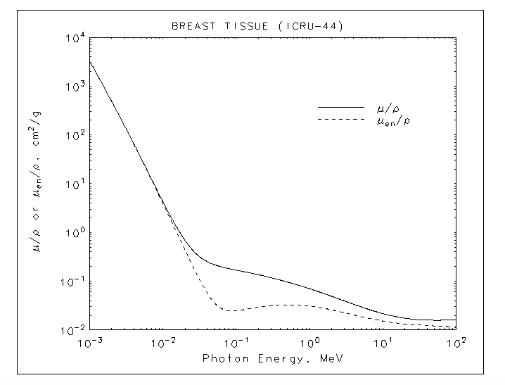

**INPUT PARAMETERS**

The program has input Parameters that are selectable by the User. This helps the User study the effects of various parameters on the output

The input Parameters are as follows

* Four types of cancer which show up on the Image with varying tissue densities (2x, 5x, 10x ,30x of the breast tissue). The sizes of each type are selectable by the user.
* The Intensity of the Initial Energy (Io) which can be adjusted depending on the density of the breast Tissue.
* Size of the Breast.

**OUTPUT MEASURES:**

**The output for the GUI will have two windows**

* **First window:** will show a Figure of the Breast Phantom. The size of the Image generated is 1000 X 1000 The phantom image shows the position, size and density of various cancerous tissues.
* **Second window:** generates a graph for intensity of the output in each of the 1000 slices of the image, which gives more accurate result on the location of the cancer.

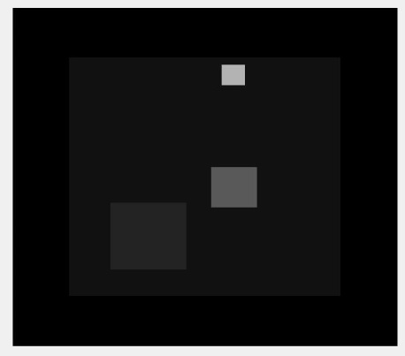

**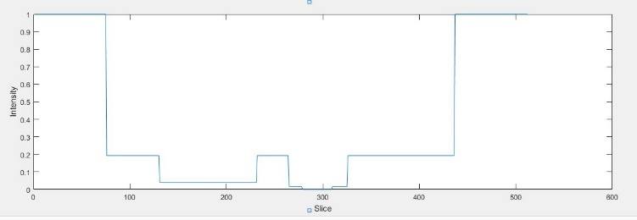**

**CONSTRAINTS**

**BREAST TISSUE DENSITY**

Breast tissue is a combination of fat, fibrous, and glandular tissue. Fatty tissue appears uniform and dark on mammography, whereas the network of fibrous and glandular tissues is more radiopaque. The standard breast reporting system, BI-RADS, includes four categories for reporting breast density.

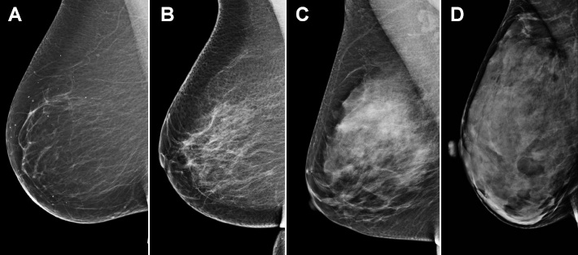

**Figure 1. BI-RADS categories of breast density. (A)** almost entirely fatty; **(B)** scattered areas of fibro glandular density, **(C)** heterogeneously dense; and **(D)** extremely dense.

For the purpose of this study we have used the Density of Breast Tissue as Category (A) where the breast primarily consists of the Adipose Tissue.

Our program uses set values for breast tissue from NIST.gov website while in the medical imaging field different breast tissue attenuation coefficients and densities are considered.

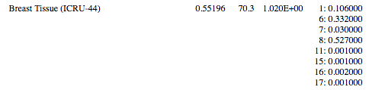

**Figure showing the Breast Tissue Values Used from Nist .gov**

**CANCER TISSUE DENSITY**

we use is the ratio of 2x, 5x, 10x and 30x of the breast tissue's values to create the cancer values because NIST.gov has no data for any sort of cancer tissues that we could find.

**LOCATION OF CANCER**

For the purpose of the study the Location of Cancer is randomized within the constraints of the Breast Phantom.

**RESULT**

Results are shown depicting the varying contrasts and intensities of different cancer types. Here Breast Size and Initial Energy are kept Constant. Image showing only **ONE** type of cancer

A screenshot of a cell phone


**Figure 1a : showing the GUI variables and values | Figure 1 b: showing the breast phantom and relative intensities of the various types of Cancer tissues and varying sizes.**

**A screenshot of a cell phone

**

**Figure 1c : showing the resulting graph**

Results are shown depicting the varying contrasts and intensities of different cancer types. Here Breast Size and Initial Energy is kept Constant. Image showing only **TWO** types of cancer

**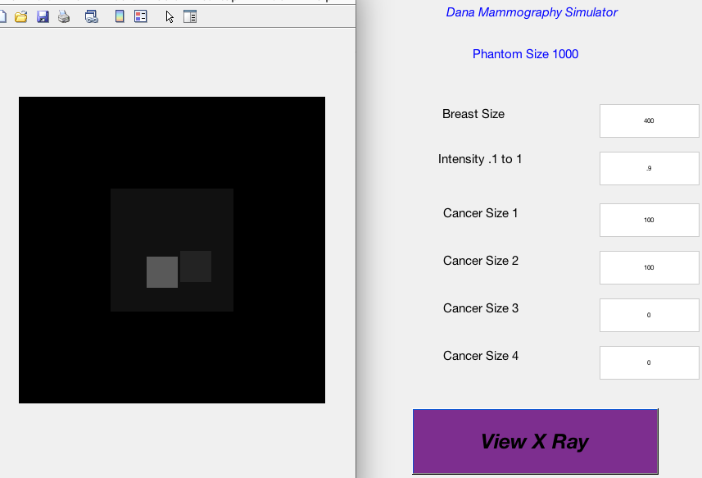**

**Figure 2a : showing the GUI variables and values | Figure 2 b: showing the breast phantom and relative intensities of the various types of Cancer tissues and varying sizes.**

**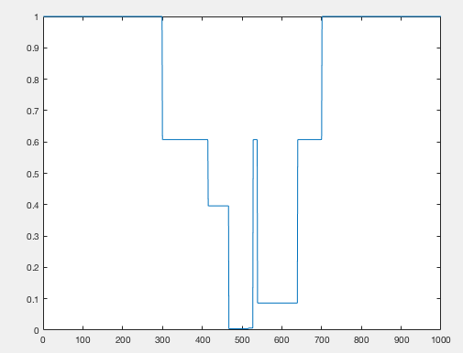**

**Figure 2c : showing the resulting graph**

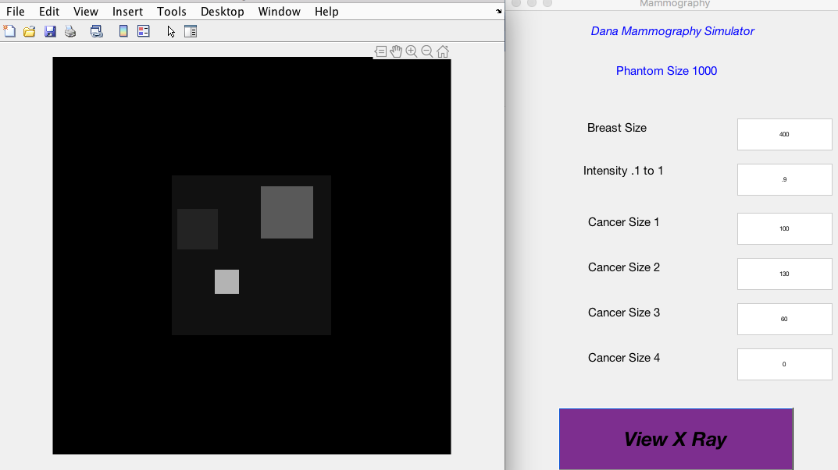Results are shown depicting the varying contrasts and intensities of Different Cancer types. Here Breast Size and Initial Energy are kept Constant. Image showing only **THREE** types of cancer

**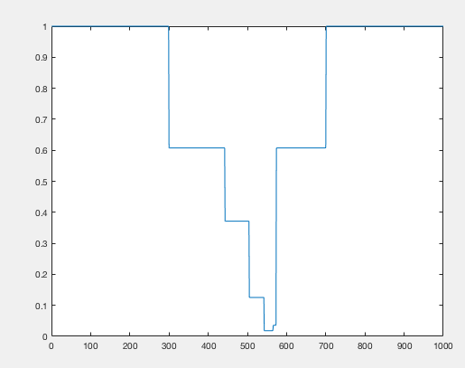Figure 3a : showing the GUI variables and values | Figure 3 b: showing the breast phantom and relative intensities of the various types of Cancer tissues and varying sizes.**

**Figure 3c: showing the resulting graph**

Results are shown depicting the varying contrasts and intensities of different cancer types. Here Breast Size and Initial Energy is kept Constant. Image showing only **FOUR** types of cancer

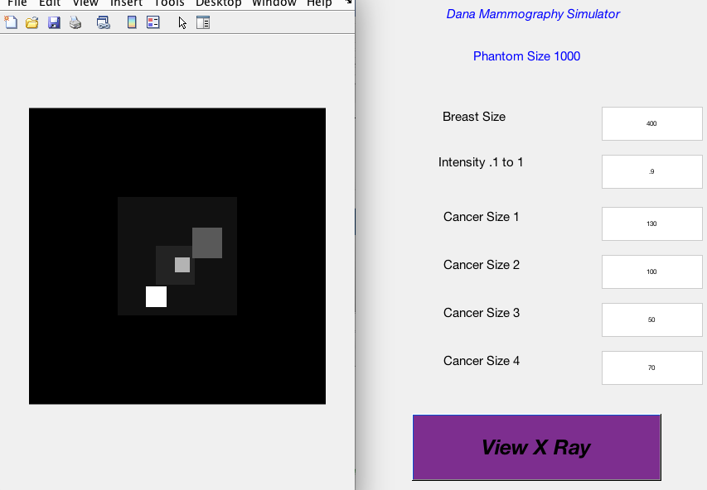

**Figure 1a : showing the GUI variables and values | Figure 1 b: showing the breast phantom and relative intensities of the various types of Cancer tissues and varying sizes.**

**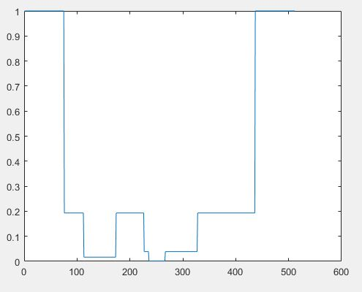**

**Figure 3c : showing the resulting graph**

**COPY OF THE CODE**

function varargout = Mammography(varargin)

gui\_Singleton = 1;

gui\_State = struct('gui\_Name', mfilename, ...

'gui\_Singleton', gui\_Singleton, ...

'gui\_OpeningFcn', @Mammography\_OpeningFcn, ...

'gui\_OutputFcn', @Mammography\_OutputFcn, ...

'gui\_LayoutFcn', [] , ...

'gui\_Callback', []);

if nargin && ischar(varargin{1})

gui\_State.gui\_Callback = str2func(varargin{1});

end

if nargout

[varargout{1:nargout}] = gui\_mainfcn(gui\_State, varargin{:});

else

gui\_mainfcn(gui\_State, varargin{:});

end

function Mammography\_OpeningFcn(hObject, eventdata, handles, varargin)

handles.output = hObject;

guidata(hObject, handles);

function varargout = Mammography\_OutputFcn(hObject, eventdata, handles)

varargout{1} = handles.output;

function viewXRay\_Callback(hObject, eventdata, handles)

set(Mammography, 'HandleVisibility', 'off');

close all;

set(Mammography, 'HandleVisibility', 'on');

im\_size = 1000;

Io = str2num(get(handles.intensityText,'String')); %since I / Io is just a ratio going to just set Io to 1 for our calculations

attenuationBreastTissue = .07031; %from website http://physics.nist.gov/PhysRefData/XrayMassCoef/ComTab/breast.html u/p=7.031E-02

densityBreast = .0102; %g/cm^2 from website http://physics.nist.gov/PhysRefData/XrayMassCoef/tab2.html

attenuationCancerTissue = attenuationBreastTissue\*2; %using a ratio, so its 2x lighter than breast tissue

densityCancerTissue = densityBreast\*2;

breastSize = str2num(get(handles.breastSizeText,'String'));

cancerSize1 = str2num(get(handles.cancerSizeText1,'String'));

cancerSize2 = str2num(get(handles.cancerSizeText2,'String'));

cancerSize3 = str2num(get(handles.cancerSizeText3,'String'));

cancerSize4 = str2num(get(handles.cancerSizeText4,'String'));

breastStart = (im\_size-breastSize) / 2;

breastEnd = breastStart + breastSize;

cancerValues = zeros(3, 7); %each column is a cancer attenuation, density, x start, x end, y start, y end, size for one cancer

%cancer 1 is 2x ratio to breast tissue

cancerValues(1,1) = 2\*attenuationBreastTissue;

cancerValues(1,2) = 2\*densityBreast;

cancerValues(1,3) = breastStart + (randi(breastSize-cancerSize1));

cancerValues(1,4) = cancerValues(1,3) + cancerSize1;

cancerValues(1,5) = breastStart + (randi(breastSize-cancerSize1));

cancerValues(1,6) = cancerValues(1,5) + cancerSize1;

cancerValues(1,7) = cancerSize1;

%cancer 2 is 5x ratio to breast tissue

cancerValues(2,1) = 5\*attenuationBreastTissue;

cancerValues(2,2) = 5\*densityBreast;

cancerValues(2,3) = breastStart + (randi(breastSize-cancerSize2));

cancerValues(2,4) = cancerValues(2,3) + cancerSize2;

cancerValues(2,5) = breastStart + (randi(breastSize-cancerSize2));

cancerValues(2,6) = cancerValues(2,5) + cancerSize2;

cancerValues(2,7) = cancerSize2;

%cancer 3 is 10x ratio to breastTissue

cancerValues(3,1) = 10\*attenuationBreastTissue;

cancerValues(3,2) = 10\*densityBreast;

cancerValues(3,3) = breastStart + (randi(breastSize-cancerSize3));

cancerValues(3,4) = cancerValues(3,3) + cancerSize3;

cancerValues(3,5) = breastStart + (randi(breastSize-cancerSize3));

cancerValues(3,6) = cancerValues(3,5) + cancerSize3;

cancerValues(3,7) = cancerSize3;

%cancer 4 is 30x ratio to breastTissue

cancerValues(4,1) = 30\*attenuationBreastTissue;

cancerValues(4,2) = 30\*densityBreast;

cancerValues(4,3) = breastStart + (randi(breastSize-cancerSize4));

cancerValues(4,4) = cancerValues(4,3) + cancerSize4;

cancerValues(4,5) = breastStart + (randi(breastSize-cancerSize4));

cancerValues(4,6) = cancerValues(4,5) + cancerSize4;

cancerValues(4,7) = cancerSize4;

imageArrayPhantom = zeros(im\_size, im\_size); %create phantom with all 0 attenuation (air space)

densityArrayPhantom = zeros(im\_size, im\_size); %air has 0 density right?!

for i=breastStart:breastEnd

for j=breastStart:breastEnd

imageArrayPhantom(i, j) = attenuationBreastTissue;

densityArrayPhantom(i,j) = densityBreast;

end

end

for k=1:4

if (cancerValues(k,7) ~=0) %if the cancer size is not 0, create it

for i=cancerValues(k,3):cancerValues(k,4)

for j=cancerValues(k,5):cancerValues(k,6)

imageArrayPhantom(i,j) = cancerValues(k,1);

densityArrayPhantom(i,j) = cancerValues(k,2);

end

end

end

end

figure;

imshow(imageArrayPhantom);

intensityArray = ones(im\_size, 1);

for col = 1 : im\_size %this is the slices going top down

length = 1;

currentAttenuation = imageArrayPhantom(1, col); %get attenuation of first row of verticle slice

currentDensity = densityArrayPhantom(1,col);

for row = 1 : im\_size

if (currentAttenuation == imageArrayPhantom(row, col))

length = length + 1; %row has same attenuation coef so add 1 to length

else

intensityArray(col) = intensityArray(col) \* (Io \* exp((-currentAttenuation)\*currentDensity\*length)); %equation u/p length

%set values for next L measurements

length = 1;

currentAttenuation = imageArrayPhantom(row,col); %set new attenuation level to measure length of

currentDensity = densityArrayPhantom(row,col);

end

end

end

%display the graph of intensities

figure

plot(intensityArray);

function slider1\_Callback(hObject, eventdata, handles)

function slider1\_CreateFcn(hObject, eventdata, handles)

if isequal(get(hObject,'BackgroundColor'), get(0,'defaultUicontrolBackgroundColor'))

set(hObject,'BackgroundColor',[.9 .9 .9]);

end

function slider1\_KeyPressFcn(hObject, eventdata, handles)

function breastSizeText\_Callback(hObject, eventdata, handles)

function breastSizeText\_CreateFcn(hObject, eventdata, handles)

if ispc && isequal(get(hObject,'BackgroundColor'), get(0,'defaultUicontrolBackgroundColor'))

set(hObject,'BackgroundColor','white');

end

function cancerSizeText1\_Callback(hObject, eventdata, handles)

function cancerSizeText1\_CreateFcn(hObject, eventdata, handles)

if ispc && isequal(get(hObject,'BackgroundColor'), get(0,'defaultUicontrolBackgroundColor'))

set(hObject,'BackgroundColor','white');

end

function cancerSizeText2\_Callback(hObject, eventdata, handles)

function cancerSizeText2\_CreateFcn(hObject, eventdata, handles)

if ispc && isequal(get(hObject,'BackgroundColor'), get(0,'defaultUicontrolBackgroundColor'))

set(hObject,'BackgroundColor','white');

end

function cancerSizeText3\_Callback(hObject, eventdata, handles)

function cancerSizeText3\_CreateFcn(hObject, eventdata, handles)

if ispc && isequal(get(hObject,'BackgroundColor'), get(0,'defaultUicontrolBackgroundColor'))

set(hObject,'BackgroundColor','white');

end

function cancerSizeText4\_Callback(hObject, eventdata, handles)

function cancerSizeText4\_CreateFcn(hObject, eventdata, handles)

if ispc && isequal(get(hObject,'BackgroundColor'), get(0,'defaultUicontrolBackgroundColor'))

set(hObject,'BackgroundColor','white');

end

function intensityText\_Callback(hObject, eventdata, handles)

function intensityText\_CreateFcn(hObject, eventdata, handles)

if ispc && isequal(get(hObject,'BackgroundColor'), get(0,'defaultUicontrolBackgroundColor'))

set(hObject,'BackgroundColor','white');

end

function edit6\_Callback(hObject, eventdata, handles)

function edit6\_CreateFcn(hObject, eventdata, handles)

if ispc && isequal(get(hObject,'BackgroundColor'), get(0,'defaultUicontrolBackgroundColor'))

set(hObject,'BackgroundColor','white');

end

function text9\_CreateFcn(hObject, eventdata, handles)

**DISCUSSIONS & CHALLENGES**

* Navigating the NIST.gov website to find values for attenuation coefficients and tissue densities. NIST.gov does not have any cancer values so we had to make our own with a ratio to the breast tissue.
* It was difficult to figure out how to create the cancers so that they would stay inside of the constraint of the breast in the phantom but was satisfying when the problem was solved.
* Last challenge was figuring out that the intensity in could only be between .1 and 1 or else the intensity graph would flip up and not make any sense because Intensity out should go down when it encounters the more attenuating and denser cancers.

**CONCLUSION**

In this project I learn how to implement a phantom for use in medical imaging and how to manipulate this phantom to produce a result that could be used to help identify abnormalities in normal tissues such as cancers.

Also learn some interesting logic for creating the 2D phantom and having a breast and then making sure the cancers we create are contained within the boundaries of the breast.

However, the hardest learned part was figuring out the algorithm to calculate the intensity of the x-ray vertical slice. I have better understanding of the way an X-Ray works after sitting down and thinking about how to translate the process into code and performing the proper mathematical calculations on the slices.

**REFERENCES**

* <http://www.sprawls.org/ppmi2/XRAYCON/>
* https://en.wikibooks.org/wiki/Basic\_Physics\_of\_Digital\_Radiography/The\_Applications
* Bushberg JT, et al. *The Essential Physics of Medical Imaging*. 3rd Ed. Section 3.3.
* <http://physics.nist.gov/PhysRefData/XrayMassCoef/intro.html>
* <http://physics.nist.gov/PhysRefData/XrayMassCoef/chap2.html>
* <http://physics.nist.gov/PhysRefData/XrayMassCoef/chap3.html>
* https://www.cancer.org/content/dam/cancer-org/research/cancer-facts-and-statistics/breast-cancer-facts-and-figures/breast-cancer-facts-and-figures-2017-2018.pdf
* <http://physics.nist.gov/PhysRefData/XrayMassCoef/ComTab/breast.html>
* <http://physics.nist.gov/PhysRefData/XrayMassCoef/tab2.html>